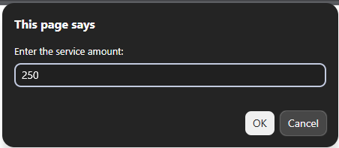
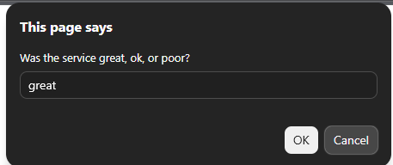
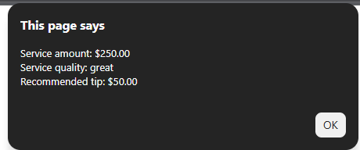
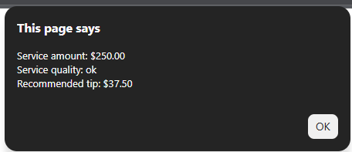
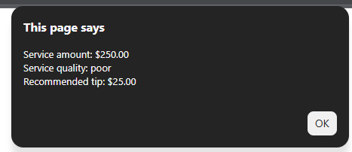
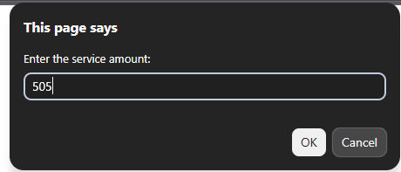
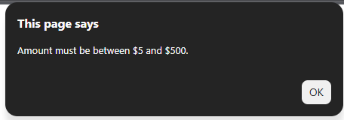

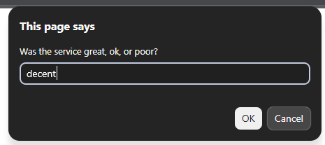
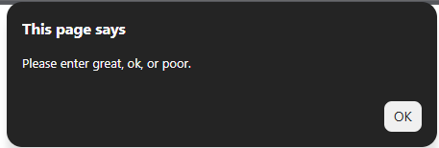

http://sotd.us/peytonmeyer/COP1801_JavaScript/Mod_4/Assignment/Mod%204/Mod4_Assignment.html

ftp://peytonmeyer%40sotd.us@ftp.sotd.us/COP1801_JavaScript/Mod_4/Assingment/Mod%204/Mod4_Assignment.html

https://github.com/Pmeyer9096/COP1801_Javascript

